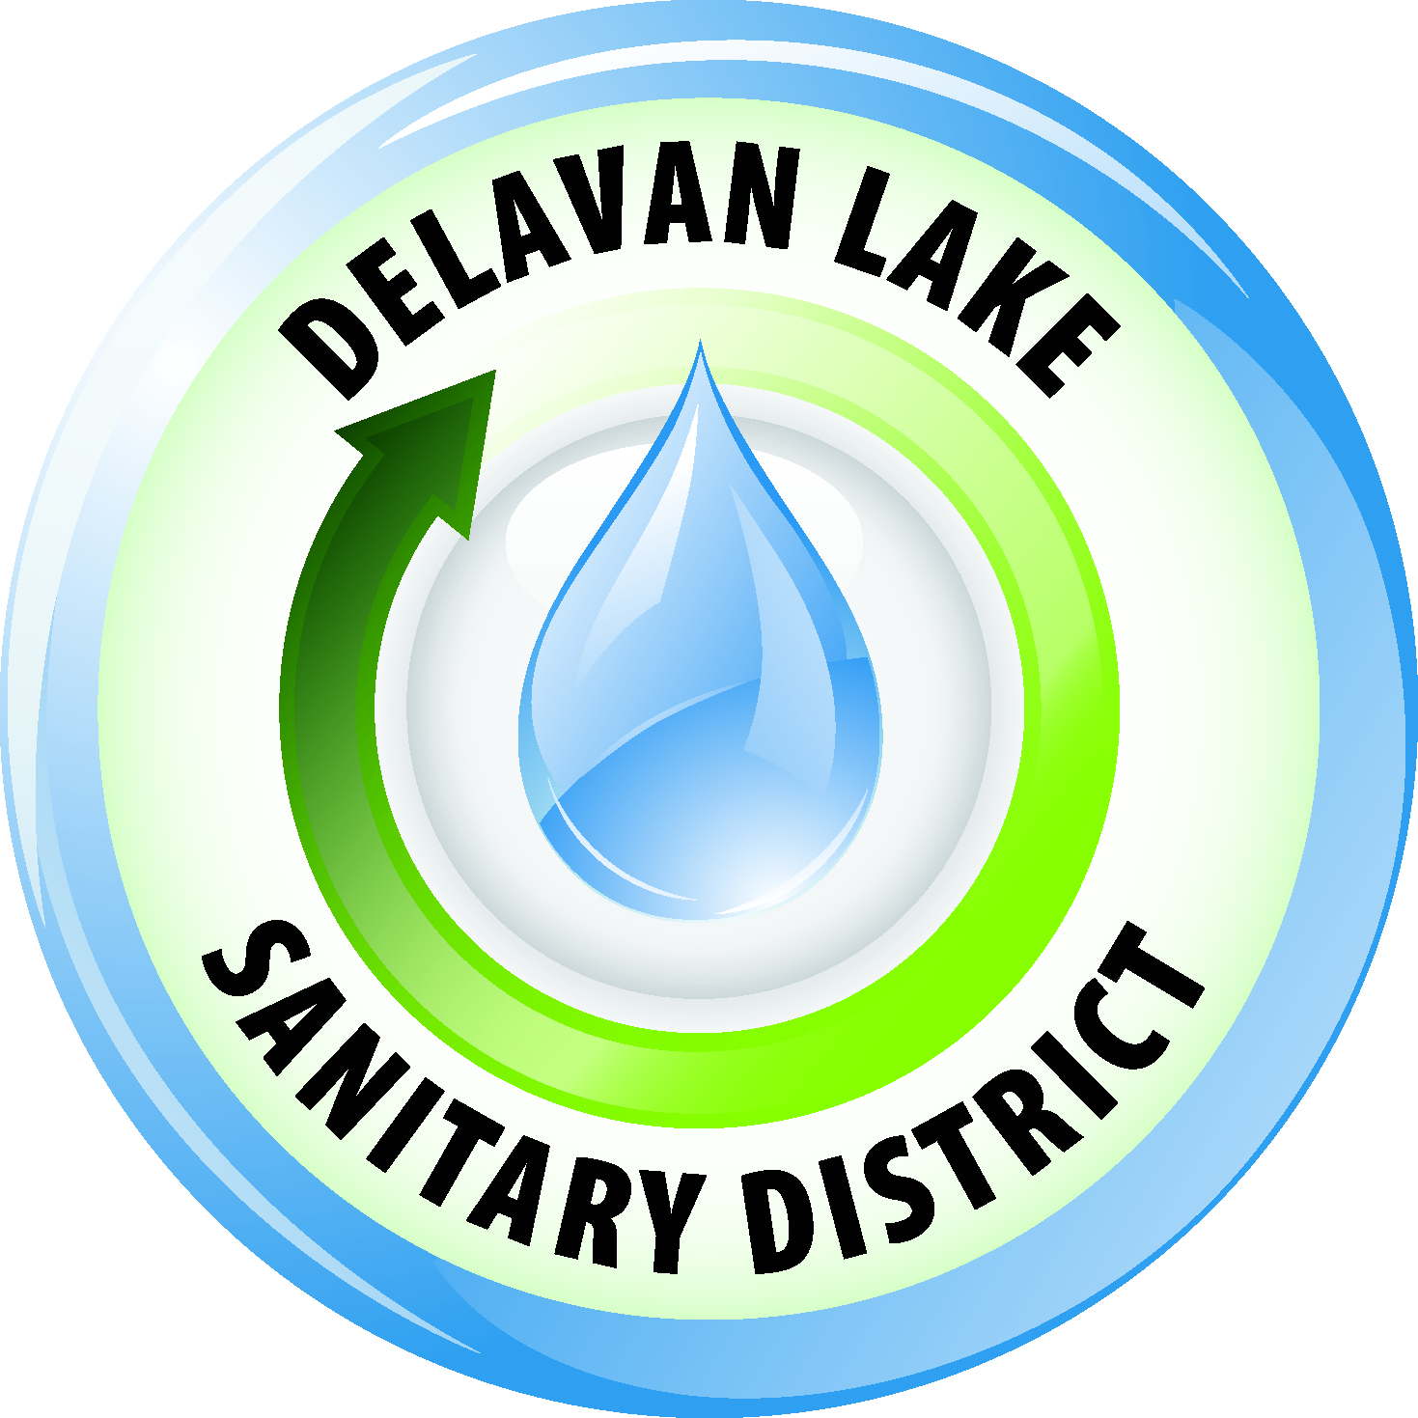
Delavan Lake Sanitary District
of the Towns of Delavan and Walworth

Tom Miller, President Richard Beers, Commissioner
Kim O’Keefe, Secretary David Reider, Commissioner Tom Johnson, Commissioner James DeLuca, Administrator

Official Notice

The Delavan Lake Sanitary District Commission will hold the Regular January Commission meeting on Wednesday, January 17th, 2018, at 9:00 A.M. in the Meeting Room at the District Headquarters located at 2990 County Road “F” South, Delavan, Wisconsin.

Agenda

- Call to order
- Roll Call
- Declaration of a quorum present for doing business
- Approval of minutes of Regular Meeting of December 13, 2017
- Comments and suggestions of citizens present regarding agenda items
- Financial
  - Review bills for payment – Check numbers 25665 through 25723
  - Acceptance of Allocation of Funds through December 31, 2017
  - Financial Statements for periods ending December 31, 2017
- Administrator’s Monthly Report
- Lake Committee Report
- Discussion/possible action regarding 2250 Highway 50 connection & fees
- Discussion/possible action regarding 2018 weed harvesting concerns – offloading & disposal sites – updates.
- Discussion/possible action or confirmation of next meeting date
- Consideration of Future Agenda Items & Policy
- Adjournment

Posted January 12, 2018

Any person who has a qualifying disability as defined by the Americans with Disabilities Act that requires the meeting or materials to be in an accessible location or format must contact the Delavan Lake Sanitary District, 2990 South County Road F, Delavan, Wisconsin at least twenty-four (24) hours prior to the commencement of the meeting so that necessary arrangements can be made to accommodate the request.

The Delavan Lake Sanitary District is an Equal Opportunity Employer

